SCHOOL OF COMPUTER SCIENCE AND ARTIFICIAL INTELLIGENCE |  |  |  |  | DEPARTMENT OF COMPUTER SCIENCE ENGINEERING
Program Name: B. Tech |  |  |  | Assignment Type: Lab |  |  | Academic Year:2025-2026
Course Coordinator Name |  |  |  | Dr. Rishabh Mittal
Instructor(s) Name |  |  |  | Mr. S Naresh Kumar  Ms. B. Swathi  Dr. Sasanko Shekhar Gantayat  Mr. Md Sallauddin  Dr. Mathivanan  Mr. Y Srikanth  Ms. N Shilpa  Dr. Rishabh Mittal (Coordinator)  Dr. R. Prashant Kumar  Mr. Ankushavali MD  Mr. B Viswanath  Ms. Sujitha Reddy  Ms. A. Anitha  Ms. M.Madhuri  Ms. Katherashala Swetha  Ms. Velpula sumalatha  Mr. Bingi Raju
CourseCode |  |  | 23CS002PC304 | Course Title |  | AI Assisted Coding
Year/Sem |  |  | III/II | Regulation |  | R23
Date and Day  of Assignment |  |  | Week7 – Monday | Time(s) |  | 23CSBTB01 To 23CSBTB52
Duration |  |  | 2 Hours | Applicable to  Batches |  | All batches
Assignment Number: 13.1(Present assignment number)/24(Total number of assignments)
 | Q.No. | Question |  |  |  |  |  | Expected Time  to complete
 | 1 | Lab 13: Code Refactoring – Improving Legacy Code with AI Suggestions  Lab Objectives:  - Identify code smells and inefficiencies in legacy Python scripts.  - Use AI-assisted coding tools to refactor for readability, maintainability, and performance.  - Apply modern Python best practices while ensuring output correctness.  Task Description #1 (Refactoring – Removing Code Duplication)  - Task: Use AI to refactor a given Python script that contains multiple repeated code blocks.  - Instructions:  - Prompt AI to identify duplicate logic and replace it with functions or classes.  - Ensure the refactored code maintains the same output.  - Add docstrings to all functions.  - Sample Legacy Code:  # Legacy script with repeated logic  print("Area of Rectangle:", 5 * 10)  print("Perimeter of Rectangle:", 2 * (5 + 10))  print("Area of Rectangle:", 7 * 12)  print("Perimeter of Rectangle:", 2 * (7 + 12))  print("Area of Rectangle:", 10 * 15)  print("Perimeter of Rectangle:", 2 * (10 + 15))  - Expected Output:  - Refactored code with a reusable function and no duplication.  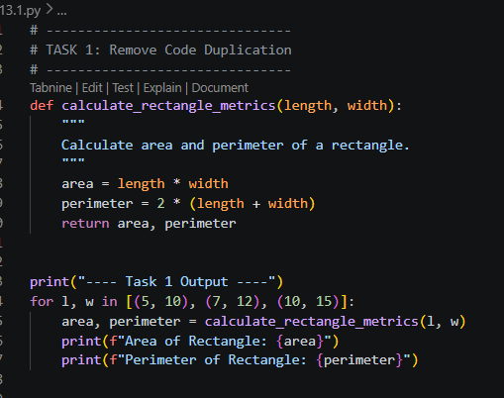  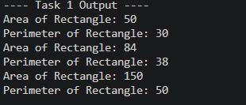  Task Description #2 (Refactoring – Optimizing Loops and Conditionals)  - Task: Use AI to analyze a Python script with nested loops and complex conditionals.  - Instructions:  - Ask AI to suggest algorithmic improvements (e.g., replace nested loops with set lookups or comprehensions).  - Implement changes while keeping logic intact.  - Compare execution time before and after refactoring.  - Sample Legacy Code:  # Legacy inefficient code  names = ["Alice", "Bob", "Charlie", "David"]  search_names = ["Charlie", "Eve", "Bob"]  for s in search_names:  found = False  for n in names:  if s == n:  found = True  if found:  print(f"{s} is in the list")  else:  print(f"{s} is not in the list")  - Expected Output:  - Optimized code using set lookups with performance comparison table.  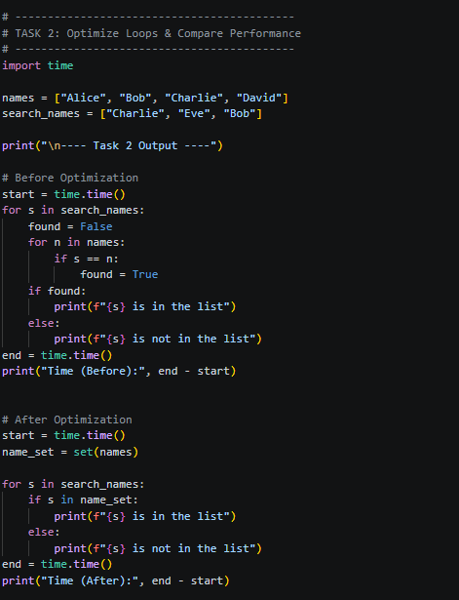  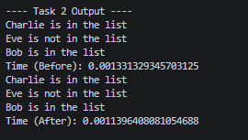  Task Description #3 (Refactoring – Extracting Reusable Functions)  - Task: Use AI to refactor a legacy script where multiple calculations are embedded directly inside the main code block.  - Instructions:  - Identify repeated or related logic and extract it into reusable functions.  - Ensure the refactored code is modular, easy to read, and documented with docstrings.  - Sample Legacy Code:  # Legacy script with inline repeated logic  price = 250  tax = price * 0.18  total = price + tax  print("Total Price:", total)  price = 500  tax = price * 0.18  total = price + tax  print("Total Price:", total)  - Expected Output:  - Code with a function calculate_total(price) that can be reused for multiple price inputs.  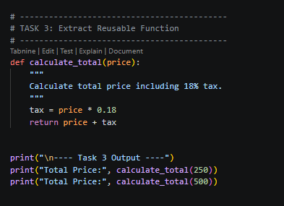  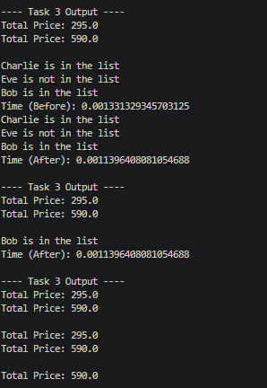  Task Description #4 (Refactoring – Replacing Hardcoded Values with Constants)  - Task: Use AI to identify and replace all hardcoded “magic numbers” in the code with named constants.  - Instructions:  - Create constants at the top of the file.  - Replace all hardcoded occurrences in calculations with these constants.  - Ensure the code remains functional and is easier to maintain.  - Sample Legacy Code:  # Legacy script with hardcoded values  print("Area of Circle:", 3.14159 * (7 ** 2))  print("Circumference of Circle:", 2 * 3.14159 * 7)  - Expected Output:  - Code with constants like PI = 3.14159 and RADIUS = 7 used in calculations.  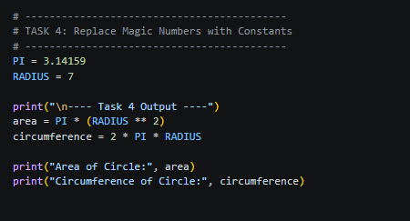  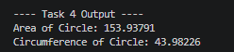  Task Description #5 (Refactoring – Improving Variable Naming and Readability)  - Task: Use AI to improve readability by renaming unclear variables and adding inline comments.  - Instructions:  - Replace vague names with meaningful ones.  - Add comments where logic is not obvious.  - Keep functionality exactly the same.  - Sample Legacy Code:  # Legacy script with poor variable names  a = 10  b = 20  c = a * b / 2  print(c)  - Expected Output:  - Code with descriptive variable names like base, height, area_of_triangle, plus explanatory comments.  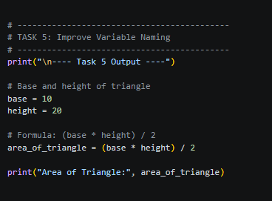  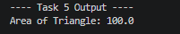  Task Description #6 (Refactoring – Removing Redundant Conditional Logic)  • Task: Use AI to refactor a Python script that contains repeated if–else logic for grading students.  • Instructions:  o Ask AI to identify redundant conditional checks.  o Replace them with a reusable function.  o Ensure grading logic remains unchanged.  • Code:  marks = 85  if marks >= 90:  print("Grade A")  elif marks >= 75:  print("Grade B")  else:  print("Grade C")  marks = 72  if marks >= 90:  print("Grade A")  elif marks >= 75:  print("Grade B")  else:  print("Grade C")  • Expected Output:  o A reusable function like calculate_grade(marks) with clean logic and docstring.  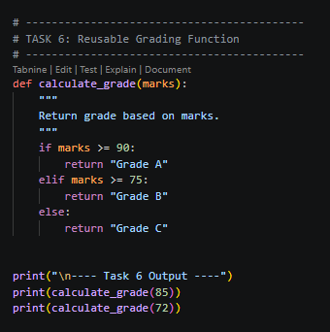  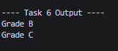  Task Description #7 (Refactoring – Converting Procedural Code to Functions)  • Task: Use AI to refactor procedural input–processing logic into functions.  • Instructions:  o Identify input, processing, and output sections.  o Convert each into a separate function.  o Improve code readability without changing behavior.  • Sample Legacy Code:  num = int(input("Enter number: "))  square = num * num  print("Square:", square)  • Expected Output:  o Modular code using functions like get_input(), calculate_square(), and display_result().  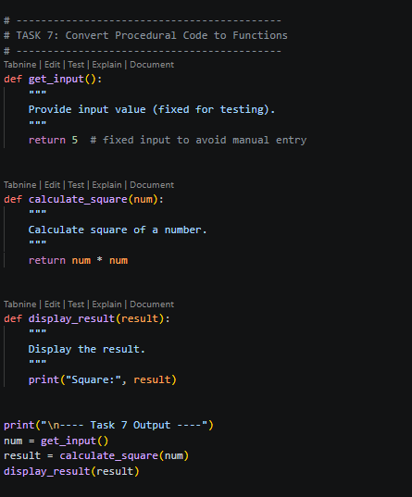  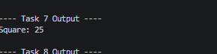  Task Description #8 (Refactoring – Optimizing List Processing)  • Task: Use AI to refactor inefficient list processing logic.  • Instructions:  o Ask AI to replace manual loops with list comprehensions or built-in functions.  o Ensure output remains identical.  • Sample Legacy Code:  nums = [1, 2, 3, 4, 5]  squares = []  for n in nums:  squares.append(n * n)  print(squares)  • Expected Output:  o Optimized version using list comprehension with improved readability  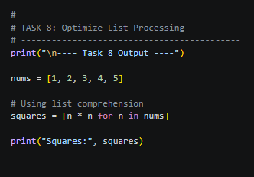  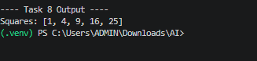 |  |  |  |  |  | Week7 - Monday

